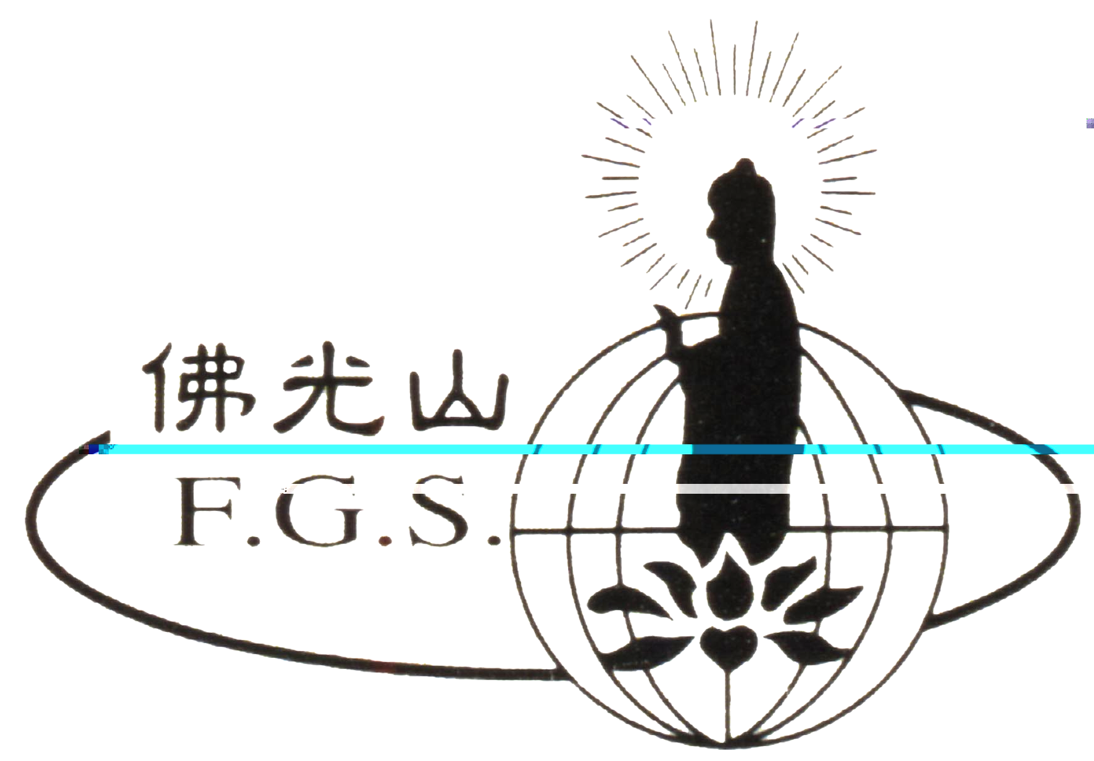
Buddha’s Light Offering
Transfer of Merits Dharma Function

Dear Sir / Madam,
Thank you for your continuous support and encouragement over the past year.
The annual Buddha’s Light Offering – Transfer of Merits Dharma Function will take place on
FGS Melbourne, FGY Art Gallery and Box Hill Buddhist centre. All are welcome to attend.

According to the Buddhist Sutras, if one offers light in a Buddhist Stupa, Buddhist Shrine or hall, s/he will receive infinite merits. The following is a summary of the types of merits that are gained:
1) One will have beautiful and bright eyes, beautiful appearance, and a healthy and long life.
2) One will have the wisdom to tell between right and wrong, be free from illusions, and always be mindful of virtue and kindness.
3) One will have virtuous company, accomplish things with will, and a wealthy and comfortable life.
4) One will be reborn in a noble and respectable family; and upon passing away, one will see the Buddha and be reborn in heaven and reach the ultimate Path to liberation.
FGS Melbourne and its local branch temples offer light offering services for those who wish to make an offering to the Buddhas and Bodhisattvas. Daily chanting services are carried out twice a day by the reverends of the temple, and special chanting services also take place on the new moon’s days and full moon’s days of each lunar month so as to transfer the merits to all protectors of the Dharma.
Venue | Date | Address
FGS Melbourne | Transfer of merits: Jan 16 (Sun)10:00am  Light Offerings: Feb 13 (Sun)10:30am | 89 Somerville Rd.,Yarraville 3013  Tel:9314 5147 Fax:9314 2006
FGY Art Gallery | Transfer of merits: Jan 15 (Sat)10:30am  Light Offerings: Feb 12 (Sat)10:30am | 141 Queen St., Melbourne 3000  Tel:9642 2388 Fax:9642 3288
Box Hill Buddhist Centre | Transfer of merits: Jan 16 (Sat)10:00am  Light Offerings: Feb 12(Sat)10:00am | 24A Rutland Rd., Box Hill 3128  Tel:9890 8188 Fax:9890 5831

(Please make all cheques payable to IBCV)
With the Blessings of the Triple Gem

FO GUANG SHAN MELBOURNE

2011 Fo Guang Shan Melbourne Buddha’s Light Offering Registration Form
Family A$100 per annum Personal A$60 per annum
Name | For |  | Venue |  |  | Amount | Address | Tel
Name | Family | Personal | Yarraville | Art gallery | Box Hill | Amount | Address | Tel
Date： Received by：

